Zomato API Case Study

The dataset is highly skewed toward the cities included in Delhi-NCR. So, we will summarise all the other cities in Rest of India while those in New Delhi, Ghaziabad, Noida, Gurgaon, Faridabad to Delhi-NCR. Doing this would make our analysis turn toward Delhi-NCR v Rest of India.

1. Plot the bar graph of number of restaurants present in Delhi-NCR vs Rest of India.

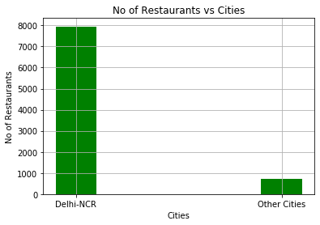

* From the graph, we can say that more no of Restaurants are present in the cities under Delhi-NCR than the cities under Rest of India.
* The no of Restaurants under Delhi-NCR are 7947
* The no of Restaurants under other cities are 705

1. Find the cuisines which are not present in restaurant of Delhi NCR but present in rest of India. Check using Zomato API whether this cuisines are actually not served in restaurants of Delhi-NCR or just it due to incomplete dataset.

* The Following are the Cuisines which are not present in Restaurants of Delhi-NCR but present in Rest of India:
* BBQ
* Cajun
* Malwani
* German

## Find the top 10 cuisines served by maximum number of restaurants in Delhi NCR and rest of India.

* The Following are the top 10 Cuisines which are present in Restaurants of Delhi-NCR and Rest of India:
* North Indian - 3946
* Chinese - 2690
* Fast Food - 1963
* Mughlai - 992
* Bakery - 726
* Continental - 724
* Italian - 682
* South Indian - 631
* Cafe - 627
* Desserts - 597

## Write a short detailed analysis of how cuisine served is different from Delhi NCR to Rest of India. Plot the suitable graph to explain your inference.

## The following are the Graphs of Delhi-NCR and Rest of India

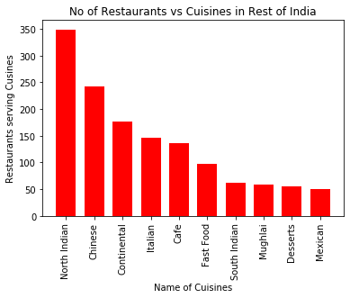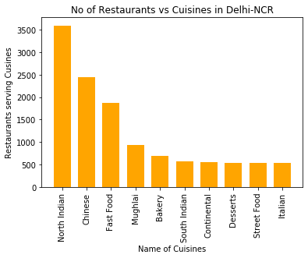

**From both the graphs we can conclude that most of the North Indian Cuisines is served in Delhi-NCR with the no of restaurants 3547 whereas in rest of India it is 349 which is very less as compared to delhi-NCR. Also the count of Restaurants serving Chinese Cuisine in More in Delhi-NCR.**

User Rating of a restaurant plays a crucial role in selecting a restaurant or ordering the food from the restaurant.

1. Write a short detail analysis of how the rating is affected by restaurant due following features: Plot a suitable graph to explain your inference.

## How does aggregate user rating varies with number of votes

## 

* Clearly as the number of votes increases the chances of getting higher ratings also increases. It is clear from the graph that any restaurants with more than 5000 votes get ratings between 4 and 5. when the voes are less than 2000, there is a diversity of ratings, which varies from 2 to 5. so for a restaurant to have a probability of getting higher aggregate rating, it should have more than 5000 votes. Also there are many restaurants having votes between between 1000 and 2000 with very good ratings, that is between 4 and 5.

## How does aggregate user rating varies with number of cuisines served

* From the graph itself, it is clear that when the number of cuisines provided increases from 3 to 8, generally the rating seems to converge between 3 and 4. restaurants providing more number of cuisines are not much likely to get higher ratings, specially when the number of cuisines provided exceeds 6. while if the restaurants provide less number of cuisines, for example 1 or 2 cuisines, they are more likely to get higher ratings. Infact many restaurants in india are providing 2 cuisines. there is a very less number of restaurants providing 8 cuisines. it seems like when a restaurant provides too many cuisines, its focus on the quality of food offered diverges. while restaurants providing less cuisines focus on the quality of food to get good aggregate ratings.

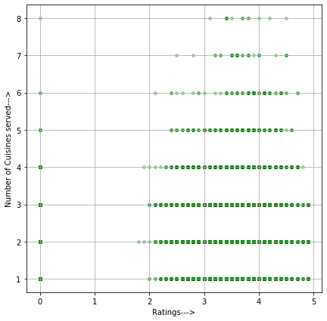

1. How does aggregate user rating varies with average cost of the restaurant.

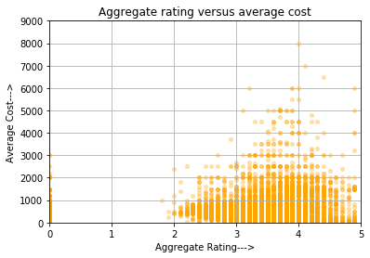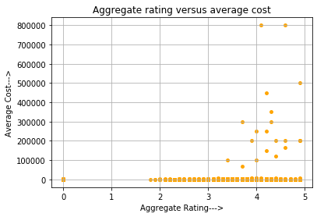

* In the first subplot we can see that when the average cost goes higher than 1 lakh the rating is generally between 4 and 5, and of course it should be like that only, because when the average cost is too high itself, the food quality should also be at its peak. This subplot doesn't give us much details about the variation of rating with the average cost. The second subplot is made by narrowing the range of average cost for two. As the average cost goes in between 2000, to 6000, it seems like the food is not worth the money because in that case the average rating is generally between 3 and 4. whereas when the average cost is between 1000 to 2000, the rating varies from 3 to 4.5 mostly. But for the higher price ranges the rating is between 3 and 4.

## How does the aggregate user rating varies with restaurants serving some specific cuisines.

* From the above histogram plot, it is clear that North Indian cuisine is the best rated among all the cuisines in all the aggregate ranges. After it comes the Chinese cuisines, it is rated between 3 to 4 maximum number of times. Then we have Fast Food, which has been rated between 3 to 4 stars maximum number of times. after these comes Mughlai and Italian cuisines.it seems like people like the Italian cuisines very much because it has a considerable rating between 3 to 4 and 4 to 5 also.

# Find the weighted restaurant rating of each locality and find out the top 10 localities with more weighted restaurant rating?

# Weighted Restaurant Rating=Σ (number of votes * rating) / Σ (number of votes) .

* Following are the top 10 localities with more weighted restaurant rating
  + Marshalltown
  + Barwa Towers, Al Sadd
  + West Park
  + New Tampa
  + The Milk District
  + Taman Impian Jaya Ancol, Ancol
  + DIFC
  + City and Suburban
  + Pondok Aren
  + Cengkareng

## Visualization

## Plot the bar graph top 15 restaurants have a maximum number of outlets.

## 

## Plot the histogram of aggregate rating of restaurant( drop the unrated restaurant).

## 

## Plot the bar graph top 10 restaurants in the data with the highest number of votes

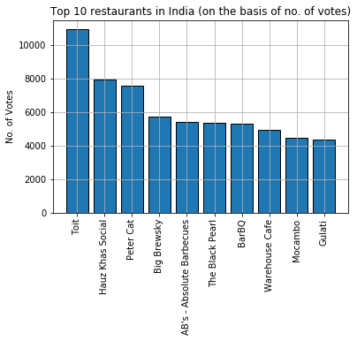

## Plot the pie graph of top 10 cuisines present in restaurants in the USA

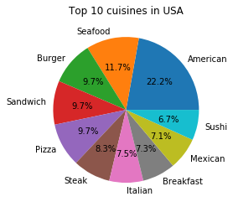

## Plot the bubble graph of a number of Restaurants present in the city of India and keeping the weighted restaurant rating of the city in a bubble